0Vaishnavi Guda  
Michael Gildein  
Web Technologies  
MSIS_517L  
April 18, 2017

Assignment 8

**Q1.**

**Step-1**

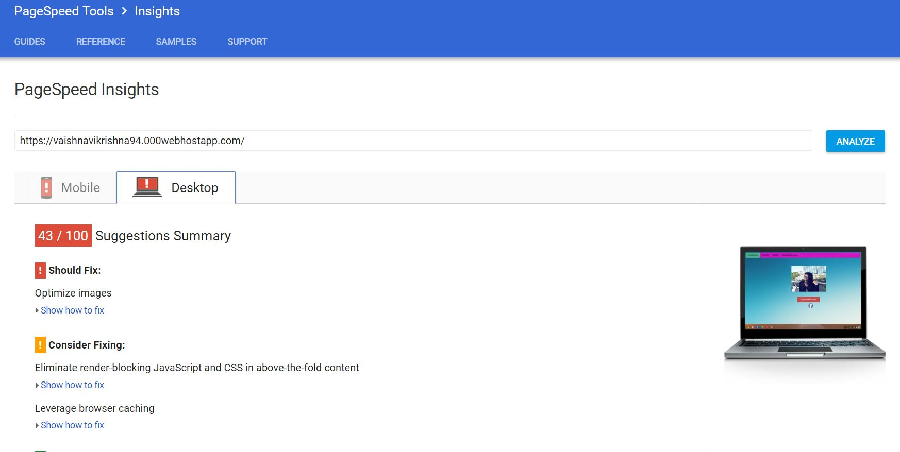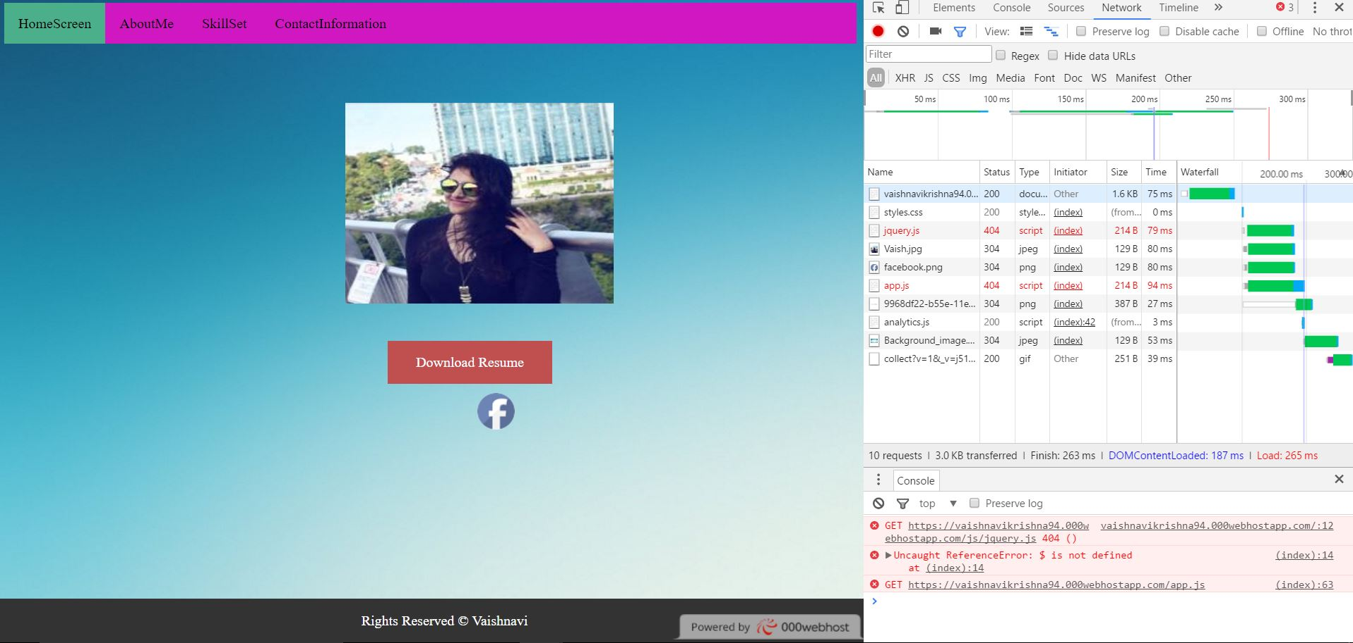

**Step-2**

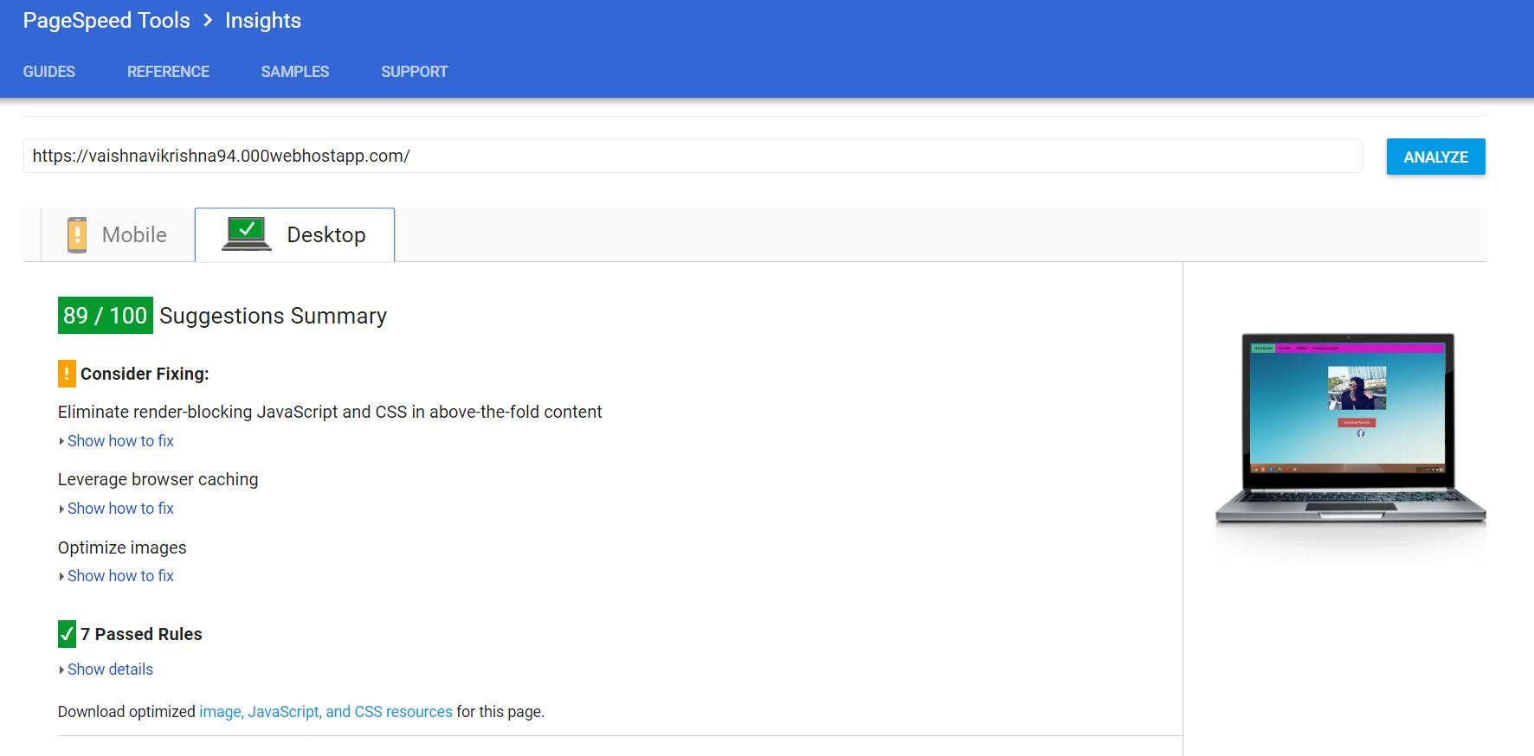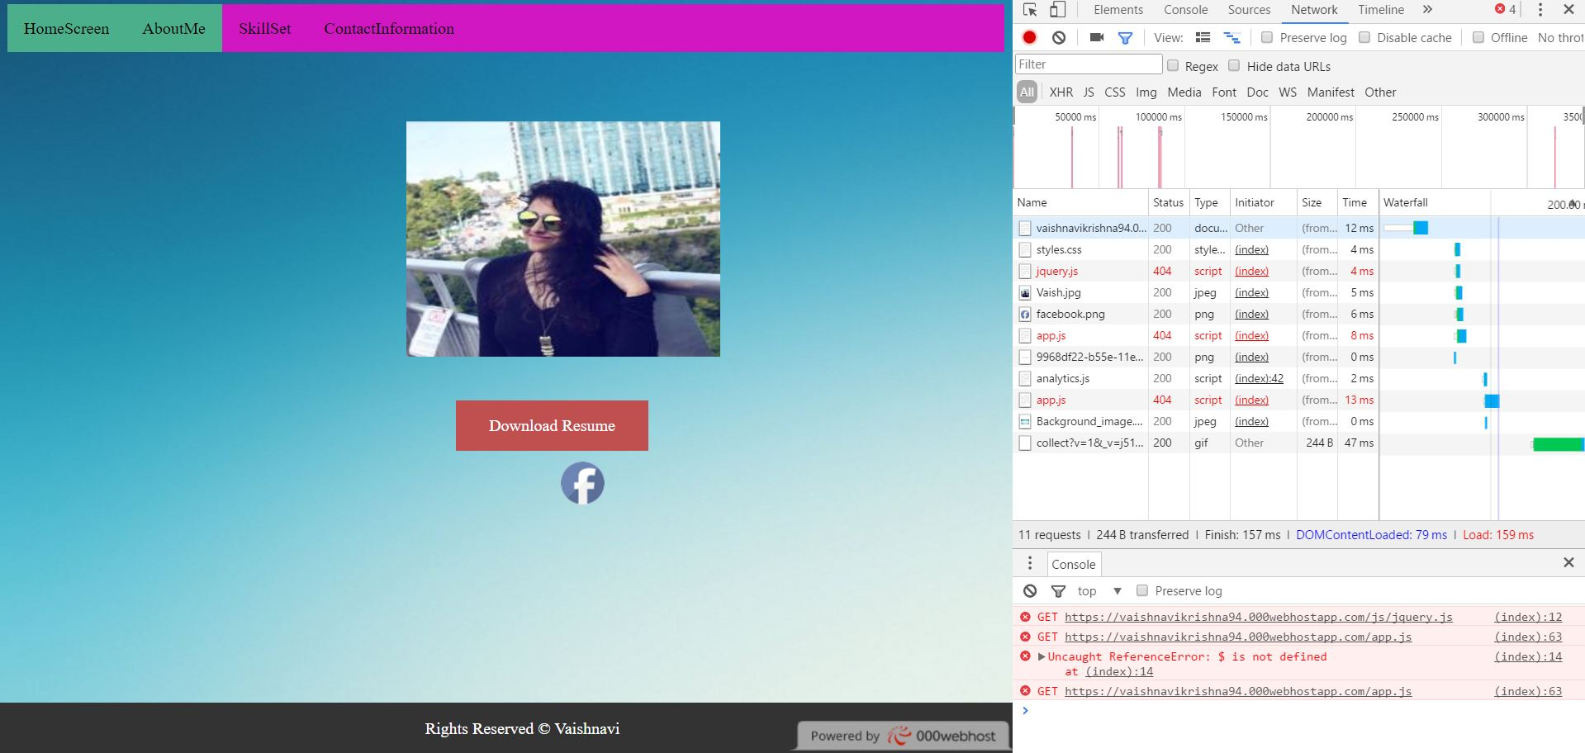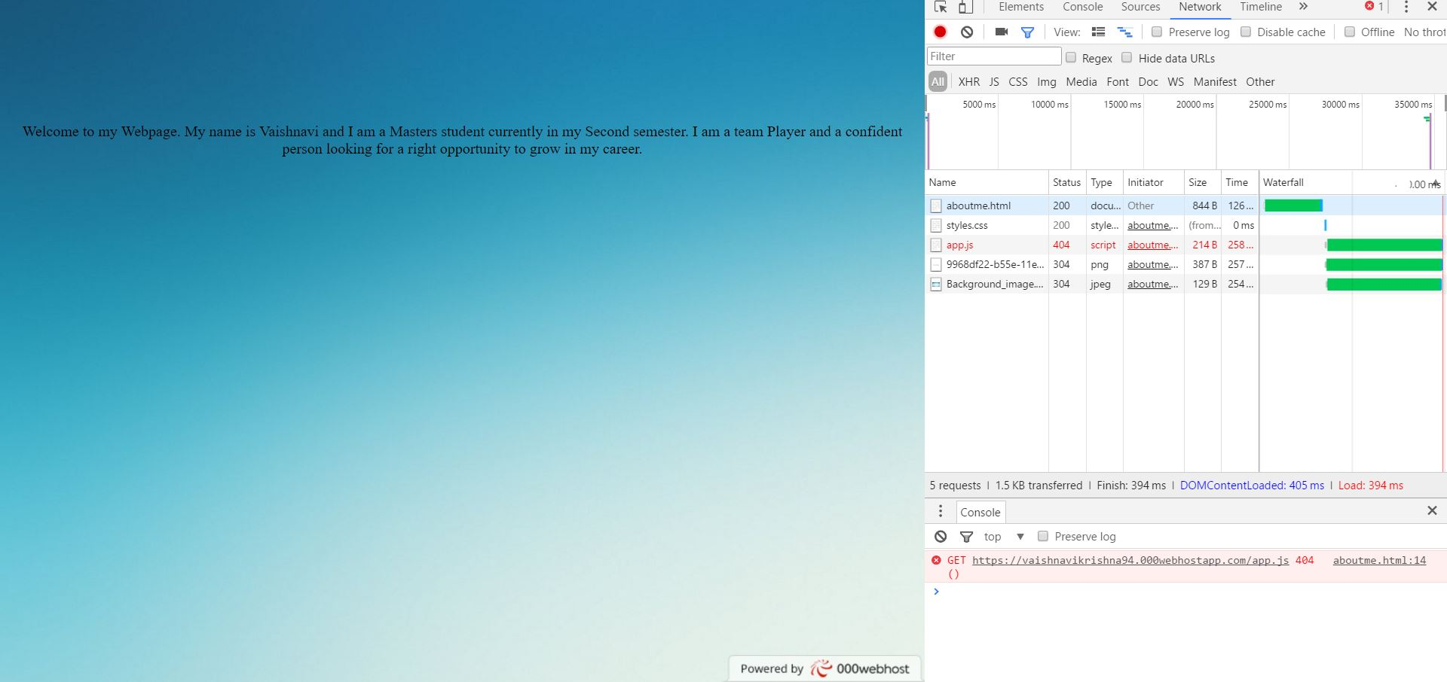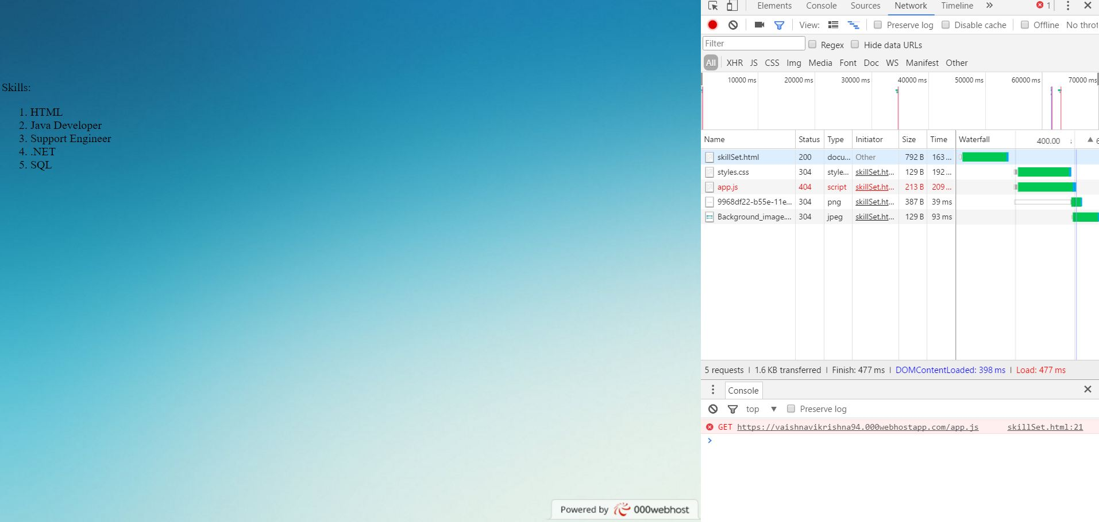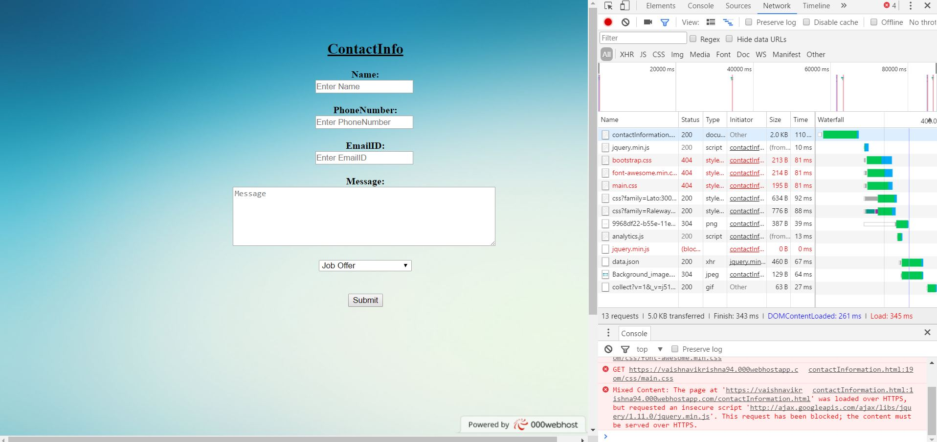

Step-3

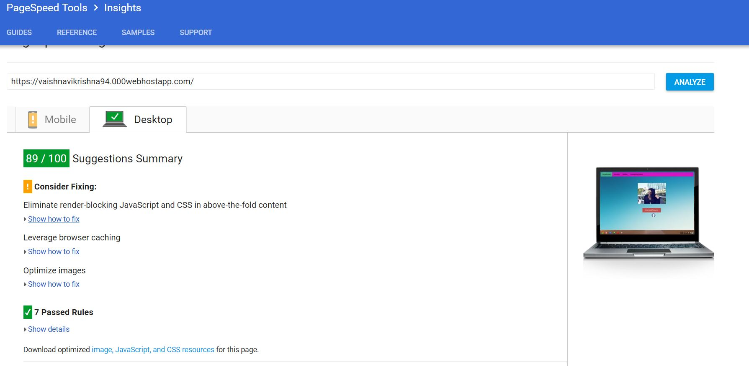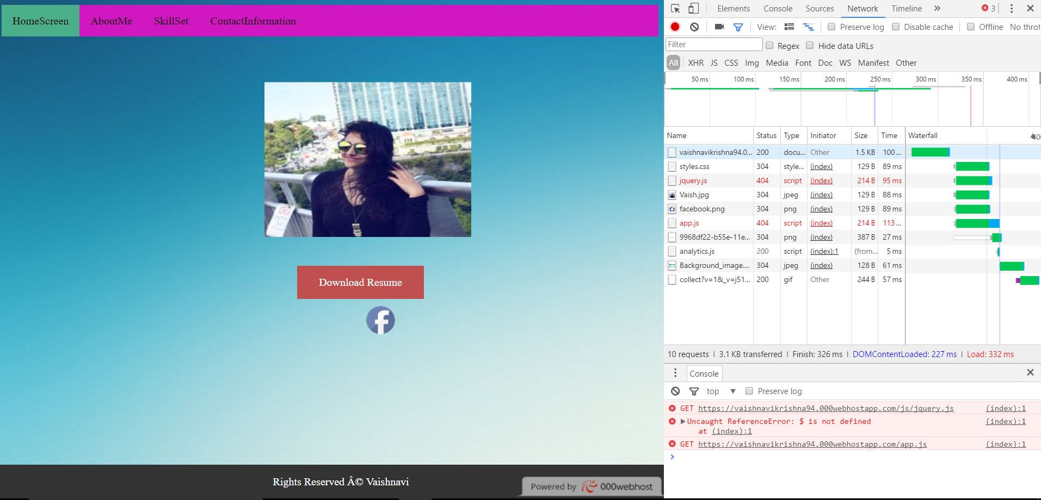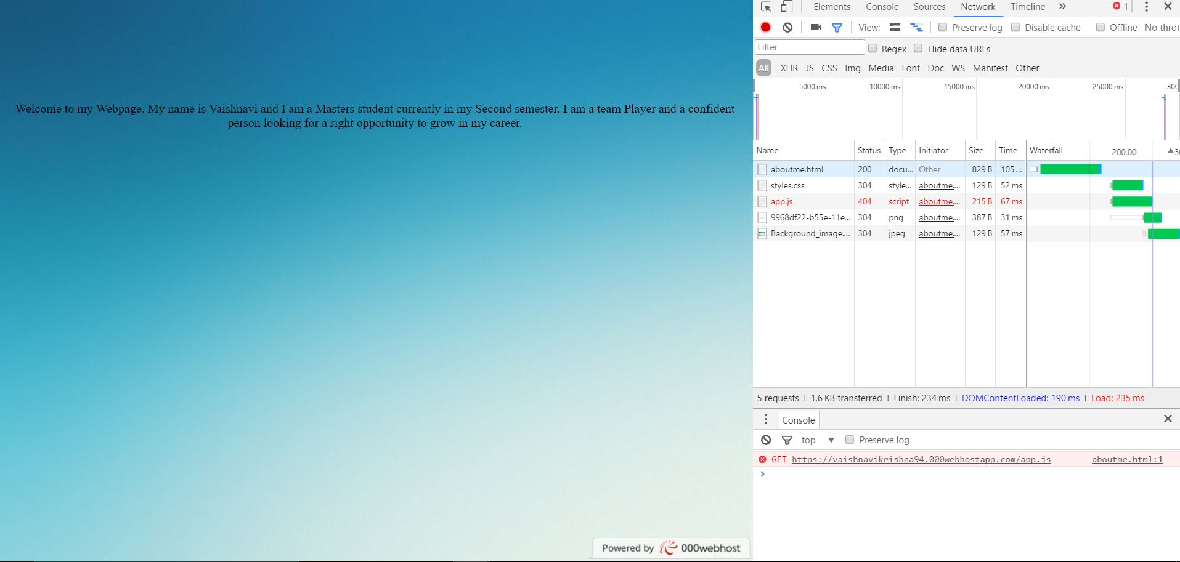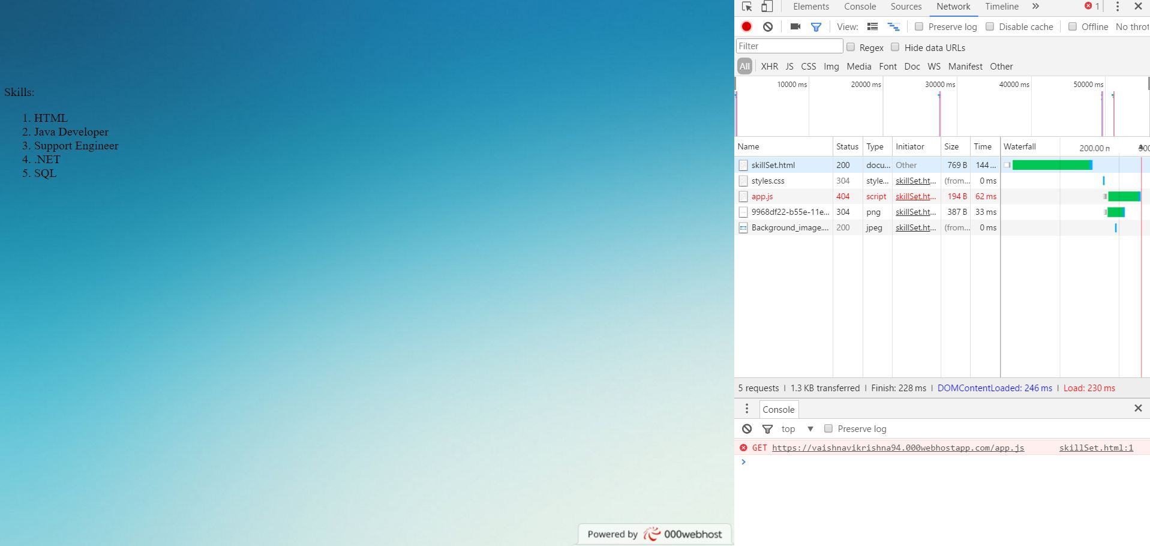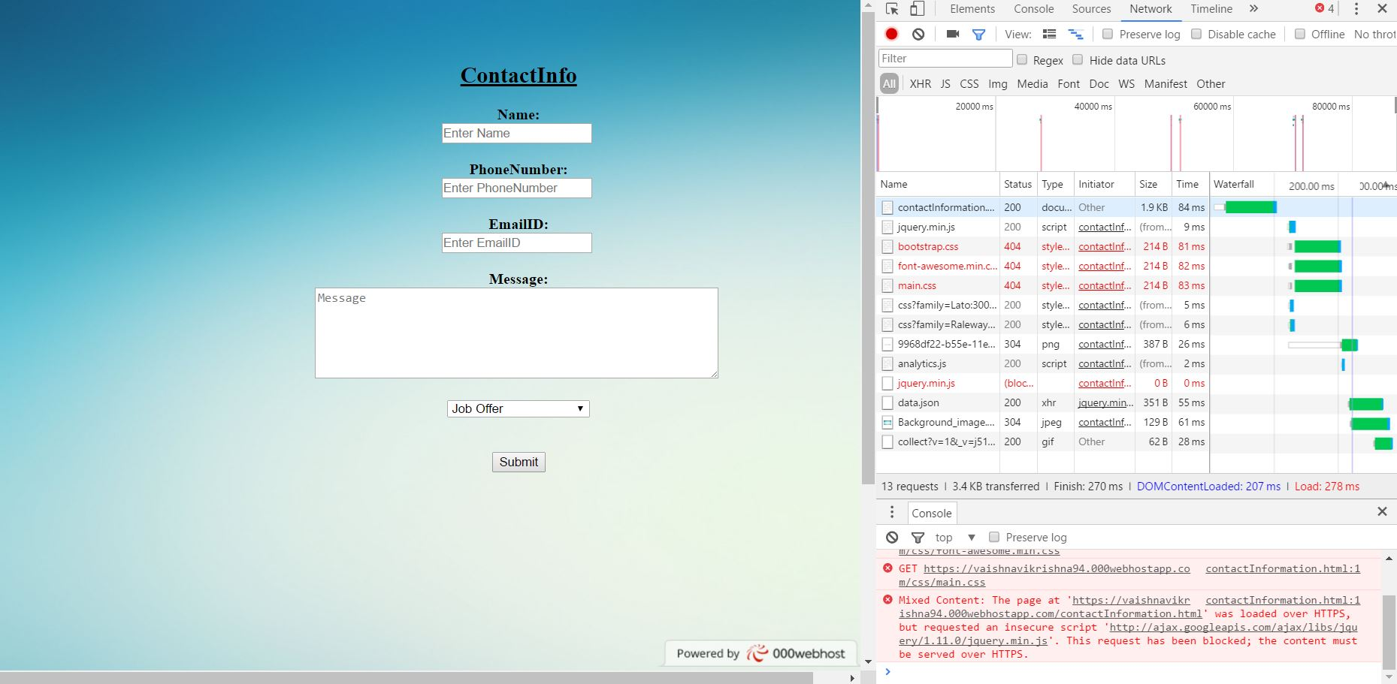

**Q2. How much of a performance increase were you able to gain by taking these simple actions?**

There was a huge improvement in the Google page speed insight after following these steps. Page loading speed brought down from seconds to milliseconds, which makes my page give more hits from the users. But, there is no human readability in the code after minification.